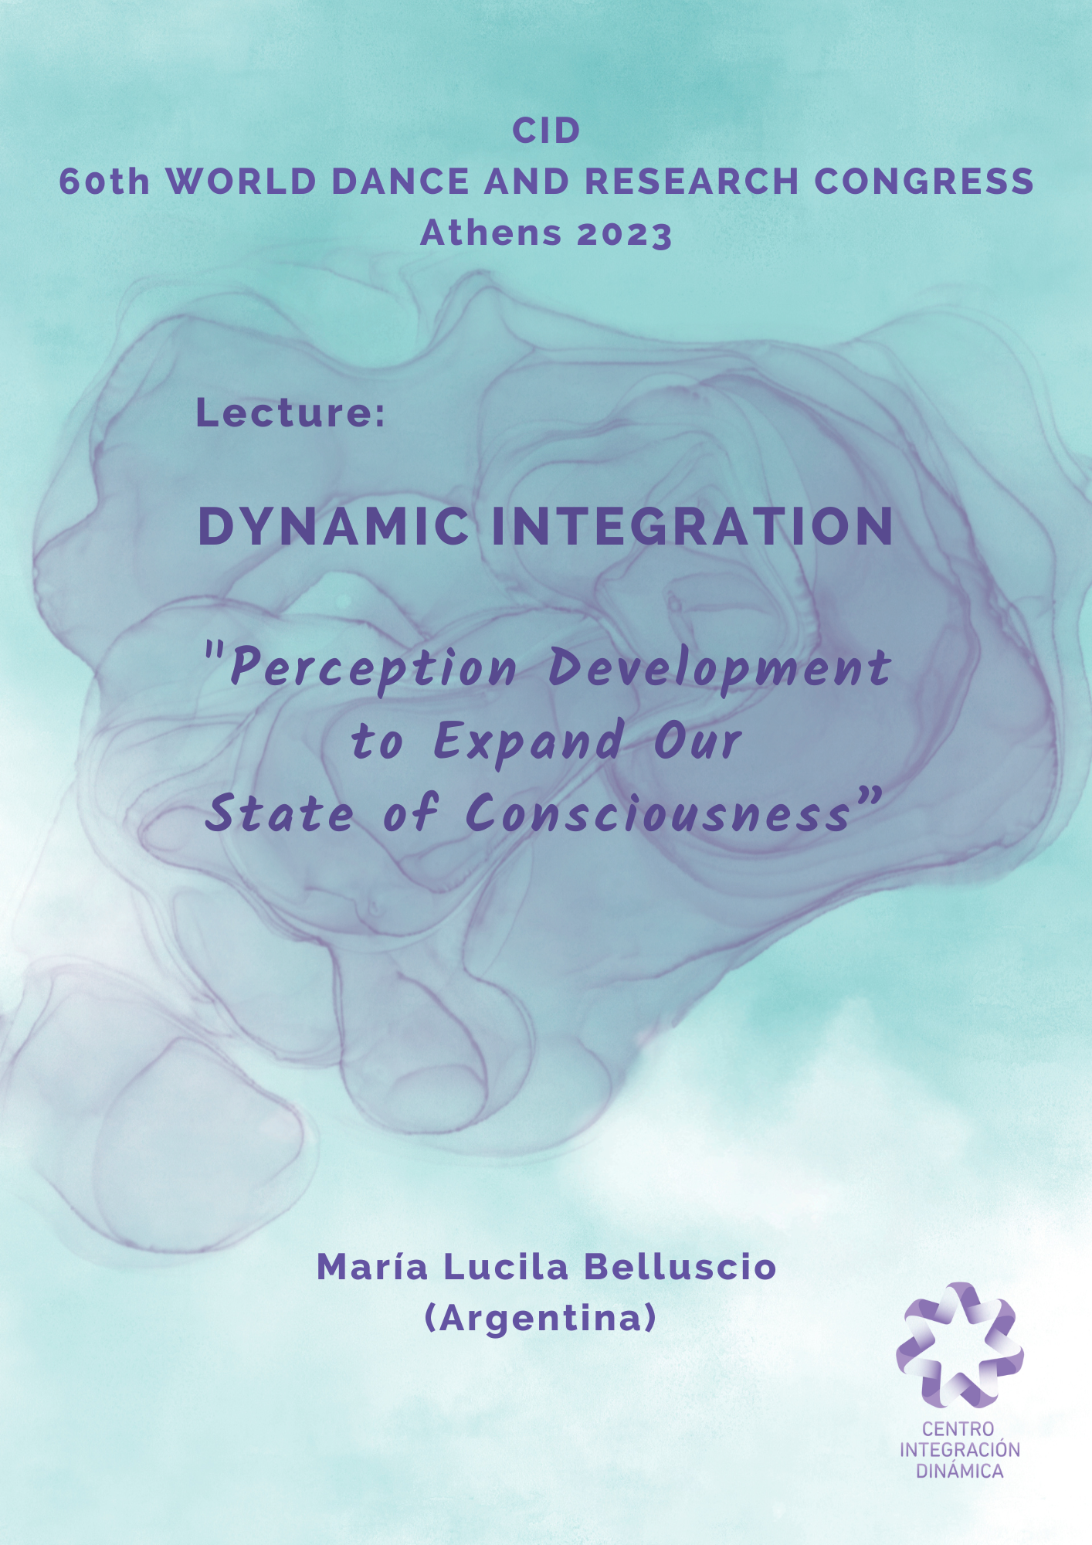

- INTRODUCTION:

Hello, my name is Lucila Belluscio. I am very thankful for having the opportunity to share my work with you. I appreciate very much your attention and hope my contribution is worth it.
As you already know, the TITLE of my lecture is:
“DYNAMIC INTEGRATION: Perception Development to Expand our State of Consciousness.”
I will be talking about perception development to achieve a special state of consciousness that I call Dynamic Integration which can widen our experience of reality in life and dance.
It is the summary of my work blending my knowledge in dance, psychology, and Eastern practices. I hope you enjoy it!
About me, I will just mention that my career was always influenced by willing consciousness development exploration.
I had the fortune of researching together with my Indian teacher, who guided me in my developing my perception and mind skills for 18 years until he left this world.

Moreover, I have been a dancer, choreographer, dance and yoga therapist, orientalist at USAL in Buenos Aires, where I live, Counselor specializing in neurophysiological-based trauma reprocessing techniques, and practice many kinds of energetic healing techniques which would take too long to present here today.
The goal of my work nowadays is to facilitate the human consciousness potential development as simply as possible.
For this, I have structured, over the last 15 years, dynamic integration (DI), which is a way of learning to voluntarily expand perception beyond our basic senses and enter an expanded state of consciousness.
The purpose of dynamic integration is to promote the expression of the state of integrated consciousness for the greater good.
I wish to contribute to raising free will from conscious decisions. By devolving perception beyond our normal limit, we become aware of the reality in an amplified way, and so, we can learn how to willingly harness it.
I found out that increasing our awareness capacity can give us quick, safe, and easy access to a new level of work.
This exploration can be a wellspring from where our dance emerges.
I encourage everyone to try this practice because many people have the idea that reality is one-whole unity but… really feeling it and being able to harness our relationship with it… well, that is something completely different. Something that I think is worth it.

This state of consciousness awards us with a strong feeling of harmony and faith in the existence that can bring out the best of us in the world.
My intention with it is to deliver a message of understanding: Comprehending we are all part of the unity of reality we could stop aggression towards each other, towards other species, and towards the planet.
If I dedicate my work to encouraging people to approach perception development is because I firmly believe that striving for inner peace is essential to then convey it outside.

- ALTERED STATE OF COUNSCIOUSNESS:

DI is considered an Altered States of Consciousness (ASC): and these are defined as alternative patterns or ‘experience configurations’ that differ in quality from a reference state perceived by the subject or a spectator.
These can be caused by two kinds of causes:

Endogenic causes:
- Pathological: Bain damage or epilepsy
- Physiological: fasting movement or sex
- Spontaneous: daydreaming, confusion

Exogenic causes:
- Pharmacological: drugs
- Psychological: mystic experiences, hypnosis, DI

- DI USES:

ID can be used for:
- LIVING, in a more conscious and peaceful way,
  - and improving relations with us, others, and the world.
- DANCING, with a much deeper quality
- MYSTICAL PRACTICE which we could also call it “integration experience” that improves and develops our existential sense of life.
- And THERAPY to prevent and heal alienation and its consequences.

- DI BENEFITS:

I have listed ID benefits for:
- Consciousness: Gaining the ability to amplify the information we consciously process.

- Sensibility: Become aware of a much wider range of stimuli.

- Creativity: we can include those in our dance and life.

- Movement Quality: the continuity perception and our relationship with it are gracefully shown in our movement (show!!!)

- Resourcefulness: we just get a lot of information we can use as we like.

- Emotional Balancing: Widening the focus allows us to contain our emotions in a harmonious context that leads us to peace going over confronting each other.

- Health: Using our influence to heal ourselves and others. (Therapy)

- Higher Skills: Develop our higher mind skills such as intuition, or telepathy.

- Freedom: consciously deciding how to harness subtle influences.

- PRACTICAL EXERCISE:

I would like to invite those who would like to experience a practical exercise, to join me now.
Look at one hand. Now, take your attention to its inside. Explore your internal sensations. Let your vision penetrate inside the skin and the sensations join your sight. Explore every single little corner of your territory. What do you feel there? Go all throw the palm and then finger by finger. How do you perceive joints? And flesh? And all together?
Go deeper inside. Reach the deepest. Take consciousness and life there. Take that to your mind. Join your mind and your hand.
Now, go all the way throw the flesh to the skin. Go forward and back from the deepest to the outside.
Reach the exterior. What do you sense? Be very attentive to the relationship where they come close together. How do exterior and interior converge?
Choose one specific part –maybe fingertips- and go there with your full consciousness.
Can you feel the outside temperature coming into your flesh?
And yours spreading into the air? Take your conscious with it. Extend it a little bit forward. Go from the deepest of your hand a little beyond your skin. Where can you reach?
Now, very slowly, approach one hand to the other. Go really slowly in order to notice the precise moment when you start feeling the other hand's presence. Can you sense some kind of connection between them before they touch one another? Try separating and going together once and again.
(LET SOME TIME!!!)
Now, on your time, let yourself come back to the interior of your body and, WHEN you feel so, get ready to go on with the lecture.

- THE CONTINUITY OF REALITY:

When we focus on the relationship between the inner and outside world, we start to discover the sensation of continuity. To talk about the reality I will be including mystical, scientific, and concepts directly raised from my experience in practicing DI.
I have guided people to become permeable to the outside, so we may sense how it affects our inside sensations, and we realize that the skin is not our limit, because perceptive awareness can expand much further.
With some little practice, our awareness grows, and we can feel what occurs in the environment and even inside others who allow us.
As humans, we are a piece of the field we live in, precisely one capable of self-perception, but this doesn’t mean that we are isolated from reality.
Isolation is in fact an idea that restricts our perception.
We can perceive ourselves as part of the intricate and ever-flowing truss of reality.
We can feel how it influences us and is then shaped by our mind in a complementary relationship in which we are a part and all at the same time.
In the DI extension experience, we discover new fields of information including electric, magnetic, different wave frequencies, temperature, pressure, our own and others’ emotions, ideas, and even spiritual stimuli. All of them constantly transform us, and we don’t even notice it!
Well, my work is about helping people to realize how we can consciously harness this bond.
We enter a new realm in which creating the dance is a collaborative matter between all the parts of what we perceive as a unit. We can either allow ourselves to let go like seaweed floating in the sea, or we can well guide the movement like pushing the water to swim.
The Dance is a web in this mental state, more like a mesh than a line. Perhaps a net created by the reality that we can completely rely on, and this experience, I must say, is deeply transforming!
Sensing the harmony of existence flowing through us is also deeply healing. Our emotional gaps are fulfilled with serenity and confidence as we participate in the consciousness of the unity that supports us.
Considering CID has a special unit for dance and spirituality I will just mention that cultures from the whole world are devoted to reaching an altered state of consciousness throw dance. It is known as a gate to the spiritual field.
Now I would like to link mysticism with willingly promoted ASC as DI dance which are also a way of entering into religious experiences.
Please notice that I associate spirituality with religion as the word’s root: the Latin “Religare” meaning “put back together”.

Guess what?!
Something that was asunder: consciousness and reality!
Therefore, the contribution I would like to present in this congress is an "integration experience approach" with the power to modify the way we perceive and harness ourselves in relation to exitance.

- DEFINING:

  - REALITY:

From Latin res, meaning thing, matter.
It would be the state or quality of being real. Or: The whole endowed with true existence. How can we know what that is?!
Some dictionaries add: “real is different from imaginary, meaning “into the mind”. At this point, we get to a struggle because how do we get to know reality?
Throw the perception process.
And where does it take place? Inside our mind! In case that be a place which is not.
How could we possibly be sure of our perception's certainty?
Maybe science and philosophy spent their whole history trying to figure that out!!!
Well, as we consciously build our ideas let us try to find out what consciousness is:

  - “CONSCIOUSNESS”:

From latin “conscio”, which comes from the particles “cum”, meaning “with” and “scio”: “growing”. Therefore, the term would refer to “knowledge apprehension”.
In psychology: is defined as Physic faculty throw which a subject perceives himself in the world.
And neuroscience pustule that consciousness manifests in brain activity, especially in cortical association areas. Consciousness is defined as a complex of information units with only a material base in the brain.

CONSCIOUSNESS PROPERTIES:

Please allow me to go a little through the consciousness properties before continuing with definitions.
Because of its immaterial composition consciousness is difficult to be studied. It is thought to be only perceptible to oneself. But I can tell you it is not! We can learn to consciously shear it -which we actually do much more than you think.
I am sure you all remember realizing you are thinking the same as someone else, or singing a song and someone tells you he was just thinking about it. That is an unconscious connection we ignore we can willingly produce.
Although it has not been scientifically proven yet, it has been stated that consciousness might participate in the quantum field just as other biological processes such as photosynthesis and birds flying which would certainly explain the conscious properties.
We need to understand that consciousness is nowadays thought of as the reality producer.
As the Nobel prize winner, Gerard Eldelman, (1929-2014) explained:

“Perception would not be an interpretation of reality, but rather its construction”.

I would also like to quote the famous German physician and mathematic, Max Plank: (1858-1947) saying:

“There does not exist the matter as such. All matter is originated and exists only by virtue of a strength that brings the particle of an atom to vibration and kips the shorter distance possible of the atom's solar system together. We must assume that behind that strength is a conscious and intelligent mind, the matrix of all matter”.

I think that understanding the inseparable relation between reality and consciousness leads us to the importance of widening our perception, improving our experience of reality, and dealing with it.

- PERCEPTION:
From the Latin Perceptionem the term means “understanding, a talking cognizance”.
It is defined by psychology as a basic cognitive process by which we create a representation of reality. It is performed by our senses, the physiological system that enables information to be gained by the mind from reality.
It is the framework that restrains every belief and creation.
More than 30 senses record information that our brains translate and interpret so that we can create a picture of reality and, in turn, create an adaptive response.
Our perceptive capacity is so expansive that our brains are constantly receiving much more new information than what we can pay attention to.
In order to manage such a flow, we need to unconsciously classify it using criteria of sense and level of importance based on our own previous experiences and transmitted in culture.
Cultural heritage is a great source of extremely functional knowledge in evolutive terms but, at the same time, it prevents us to think outside of its boundaries. If we were told, for example, that reality is material, then that is how we will perceive it.
Now, please tell me who told us that we cannot move things with our minds. Well, let’s go and get him because he prevented us to learn!!!
jejeje
Although conscious processing has a huge capacity for meticulous analysis, it is incredibly slow to produce a suitable solution when surviving depends on quick decisions. It would take weeks to consciously analyze the data gathered every second!
Therefore, from the whole information captured:
- Only 5% considered the most relevant is processed by consciousness.
- Leaving the other 95% to be resolved by unconscious pathways.
- And finally, from that 5% of stimuli that gets to achieve our awareness, most are consciously dismissed by considering them meaningless.
Tell me how many noises did you ignore since I began speaking?

- There is also a 25% of information known as preconscious that we may willingly reach. That is what we work in DI with. We widen the information access from the unconscious to the preconscious so we can consciously finally get it!

- REALITY AND CONSCIOUSNESS:

As I hope you have already noticed, Reality and Consciousness have an indivisible link.
As Hilary Putnam said:

“Reality and consciousness build together reality and consciousness.”

I would like to notice another parallel we might trace in the percentages of conscious, preconscious, and unconscious of the mind and those of matter, dark matter, and dark energy in the universe.
They match just precisely match.
- 5% is known as matter.
- 95% is unknown, being possibly divided into:
- 25% of dark matter.
- 75% of dark energy.
And comes the best part: what are those things made of???
Everything we know is that they vibrate. They are thought to be different states of something that vibrates in different frequencies.
We all wonder what that thing really is but e don’t know but may very possibly be one only vibrating thing which is everything made of.
Also, what we call matter, yes. And, what we call conscious, yes, again.
Then, please give a chance to the Integration Experience to reveal your consciousness of the vibrating universe we are a part of.

- WIDENING THE INFORMATION WE CONSCIOUSLY PROCESS IN ORDER TO EXPAND OUR MINDS

We have been training for years on the most efficient way to classify information but that is precisely what avoids us from experiencing reality in a more thorough way. So, we need to lower the previous conditioning to expand our awareness. …And the question always is: How?!!

- We can submit to direct perception by directing attention to our body’s internal sensations. These are a source of irrevocable information that helps us to focus on the direct perception path leaving judgments behind.
- Learning to consciously drive the data filtering process to allow the information we want to reach our awareness.

Extending perception, we can symbolize what education has inhibited. As a result, we can perceive far more than we are accustomed to, by voluntarily bringing some unconscious stimuli into awareness.
In dynamic integration, we learn to expand consciousness to perceive what we can all sense but is usually consigned to unconscious processing.
It is a way of consciously deciding what stimuli we want to become aware of instead of entrusting the task to the unconscious.
Let us go beyond our previous ideas of limited perception and allow us to reach the Integration State of Consciousness in which we can experience the infinite we all are a part of.
We can enter a dance much bigger than us: the universe's expressing process.
I have seen along years of running my workshops that a deep and at the same time unidentified longing is satisfied by the sensation of dancing in the Integrated State of Consciousness.
Consciousness "smells'' the reality we are ignoring and somehow is curious about it. Therefore, making it conscious provides us a feeling of "completeness," as if we had been yearning for it all our lives.
As we all know, information is power, so, as we develop the power of feeling subtle stimuli, we can decide to harness the energetic reality instead of remaining unconsciously influenced by it and not even noticing!
In the Dynamic Integration Expanded State of Consciousness, we become aware of how we connect with others. How we open or close ourselves to their influence. And how to do it on willing.
- What distance do I decide to keep with you right now?
- How do I protect myself from others’ invasive impulses?
- How to avoid what I don’t like and how to promote what I do wish?
- How to gain peace and calmness by relying on the unity’s harmony that supports us?
These tasks are addressed in a practical way in the Dynamic Integration workshop experience.

- INVITING PUBLIC TO THE CLASS:

I am therefore glad to invite you to join my class tomorrow at ……AM AT
SERAFIO CITY OF ATHENS SPORTS, CULTURE & INNOVATION CENTER.

- CONCLUSION:

PERCEPTION DEVELOPMENT CAN LEAD US TO DECIDE TO CONSCIOUSLY PROCESS A BROAD AMOUNT OF THE INFORMATION WE PERCEIVE AND WIDEN OUR REALITY EXPERIENCE.

IN THE DISC WE CAN EXPERIENCE THE INFINITE WE ARE A PART OF AND VOLUNTARILY HARNESS OUR “RELATIONSHIP” WITH IT.
(Here, please notice we have a relation with the reality we are a part of just as we can talk about the relationship we have with our body or ourselves)

ID IS A WAY OF EASILY IMPROVING OUR PHYSICAL, EMOTIONAL, AND PROFESSIONAL SKILLS.

- LAST REFLEXION:

I would like to wrap up with one last reflection:
We are not alone because our skin is not our boundary, we are much more than what we sometimes think.
I believe it is necessary to drive a society conscious of our interdependent nature.
I encourage dancers, choreographers, teachers, researchers, and all of you as communicators to spread out the Integration Concept to raise future generations adapted to the social collaborative coexisting.

Thank you very much!

Find me at my Networks:

- CUOTES AND BIBLIOGRAPHY

Ludwig, Arnold M. (Septiembre de 1966). «Altered States of Consciousness (presentation to symposium on Possession States in Primitive People)». Archives of General Psychiatry :10.1001/archpsyc.1966.01730150001001.
Hoffman, Kay (1998). The Trance Workbook: understanding & using the power of altered states. Translated by Elfie Homann, Clive Williams, and Dr Christliebe El Mogharbel. Translación edited by Laurel Ornitz. ISBN 0-8069-1765-2
Charles T. Tart. Altered States of Consciousness, Anchor Books, First Edition (1972) ISBN-13 ‏ : ‎ 978-0385067287
Philip Goff Consciousness and Fundamental Reality Oxford University Press, 2017. ISBN 0190677023, 9780190677022
Online Etymology dictionary. https://www.etymonline.com/
RAE: Diccionario de la Real Academia Española.
Penrose, Roger, Las sombras de la mente: hacia una compresión científica de la consciencia, Editorial Crítica, 1996, ISBN 84-7423-771-8.
Farthing, G. William (1992). The psychology of consciousness. Englewood Cliffs, N.J.: Prentice Hall. ISBN 9780137286683.
Online Etymology Dictionary. https://www.etymonline.com/
Ivan Antic, The Physics of Consciousness, In the Quantum Field, Minerals, Plants, Animals and Human Souls. Samkhya Publishing LYD. London, 2021. ISBN 9798742171041
Mohamed H. Abdullah^{1,2}, Anatoly Klypin^{3,4}, and Gillian Wilson^{1, “}Cosmological Constraints on Ωm and σ₈ from Cluster Abundances Using the GalWCat19 Optical-spectroscopic SDSS Catalog” The Astrophysical Journal, Volume 901, Number 2 Published 2020. The American Astronomical Society. Citation Mohamed H. Abdullah et al 2020 ApJ 901 90DOI 10.3847/1538-4357/aba619

