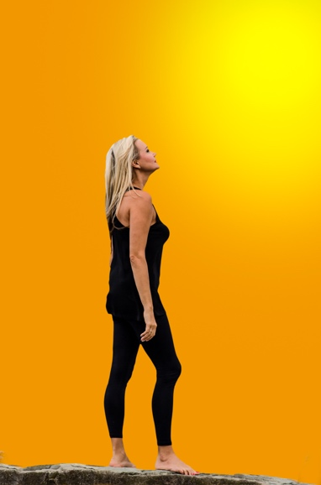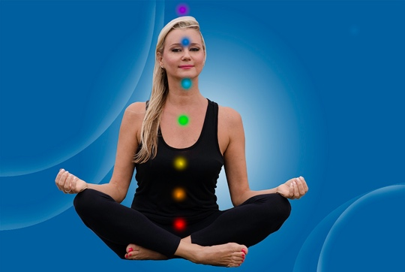
Spiritual Dance the Adamsone Method

In the spiritual dance, energy flows through the body’s chakra centres and into your movements to connect body and spirit. These dances take the form of exercises that are meant to promote balance of the body’s chakras and foster harmony among them, improving your well-being. In addition, they will help you let go of stress and negative emotions and bring healthy energy to your body. They ask you to access your emotions and express them through dance. These exercises will also help you to unlock your creativity: we all possess everything we need to dance. When we are able to connect body, mind, and spirit in dance, they become one, and this powerful life source brings new energy into our being.
Think about your being – your physical body, your spirit –and about everything that surrounds you. Look up at the sky and imagine how far it goes. Although there seems to be no end to it, the beginning is you. Everything that’s in you and around you makes you the way you are. In today’s fast-paced world, we are forced to constantly adapt to changes around us. Letting our creativity blossom and expressing ourselves through movement can make a tremendous difference in our lives and help us deal with challenges, from the pressures of every day life to ill health to emotional distress. We can unlock our creativity by becoming aware of our bodies, ourselves, how we connect to the physical world around us, and to the universe.
In Spiritual Dance the Adamsone Method you will learn:
- What are Chakras and where they are in the body.
- What color, organ, element, food, and emotions each chakra is associated.
- Chakra Balance exercises and Chakra Dance with Chakra Color Scarfs.
- Creating New and Healthy Energy with movement and letting the energy form the universe into your body with movement.
- Connecting to four classical elements of the universe: water, air, earth, and fire with movement and bringing these four elements into your body to feel complete.
- Expressing and letting go of negative and positive emotions through movement and sound.

Adamsone’s spiritual dance method, which emphasizes individual exploration and discovery, making it accessible to people of all ages, body types, and fitness levels. This series of life-affirming dances is designed to promote total well-being by harmonizing body, mind, and spirit.

www.spiritualdance.ca

